CDE 2.1 Consumer Portal
GUI Design & Integration to Back-end Services
15-May-2002

From Clinician Application

General
Until we implement BEA Portal, we need to be able to distinguish Consumer users from Clinician users. Both roles will be using the same application, and the functionality offered will be slightly different depending upon the user’s role. Therefore, we will add a temporary entry to LDAP. This entry can be removed once the Group Portal are set up in the BEA Portal

Temporary LDAP Entry
Boolean Consumer

We need a way to retrieve this information upon login authentication. How about something in LDAPUtil
Boolean isConsumer(Map certHolder)

User Registration
For the initial release of the Consumer Portal, registration is going to be handled manually. The Netscape LDAP console will be used to create Consumer users and assign passwords. The current manual process for creating client certificates will be used.

The association between the Consumer user and the ICS Person object for that user will be entered by hand when creating the user in LDAP. A new field must be added to LDAP to accommodate a unique Person ID. The unique ID will be the Person.Person_ID, which is guaranteed to be unique, provided that we set up the DB such that the sequence used to generate that value never repeats a value. When the Consumer logs in, this ID will be used to retrieve his or her Person object from ICS.

Permanent LDAP Entry
String Person_ID

The only change needed from the application is to be able to provide the Physician user with a unique Person ID. A button will be added to the Candidate List that will allow authorized Physician users to view the unique Person ID for the Person that they have identified as the Consumer user. This ID will then be used in the LDAP user creation process.

Since this change is only temporary and only for internal users, I am going to make the solution very simple. The unique ID for the Person will need to be returned from the ICS in the Person object. I will make a dynamic JavaScript routine that associates each row with the corresponding ID. When the user hits the button, only 1 person may be selected. The JavaScript routine will pop up and alert box displaying the ID.

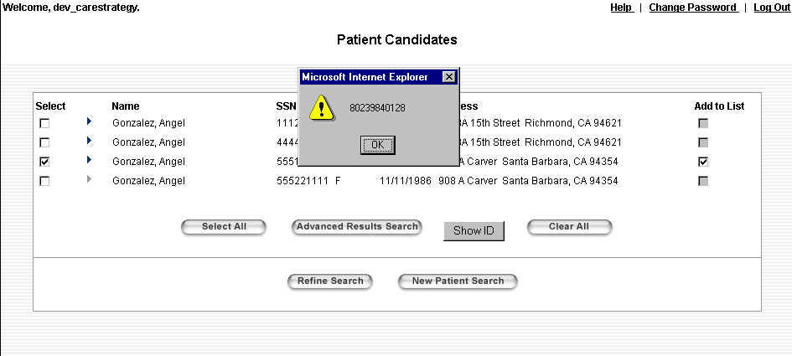

I don’t see a method in the Person object to return this value. I’m proposing:
String getUniqueID()

We don’t want all Clinician users to have access to this functionality. To conditionalize access to this feature, we will add another entry to LDAP. Again, this will only be temporary until we can use the BEA Portal Entitlements feature. Only Ken would need this entry to be true.

Temporary LDAP Entry
Boolean ClinicianAdmin

I’ll need a way to get access to this value also:
Boolean isClinicianAdmin(Map certHolder)

Physician Result Authorization
Document locAdapt.getLocator(clinDataRequest)

This is the current call to the ILS. For the Consumer Portal, the locator adapter should only return results that have been authorized. Therefore, this call needs to specify whether the call is being made from the Consumer Portal or Clinician Portal. This could be accomplished either by adding the parameter to the getLocator call or else modifying the clinDataRequest.

The resulting Document needs to contain the unique ID of the result (value of this is still pending) as well as the value of the Authorized flag. For the Consumer Portal the value of the Authorized flag is not needed, since it should always be TRUE, but it might make more sense to have the return value be consistent regardless of how it’s called.

The Clinician can authorize a Consumer to see a result only if the Consumer is registered as a CDE user. Therefore, we need to be able to search through LDAP for the Person_ID field that matches the candidate being searched.

boolean findUser(Person selectedPerson)

If the candidate being searched is found, then the Clinician may authorize the result. This method should update the permanent data store, saving the value of the authorization with the result.

void authorizeResult(Person selectedPerson, String resultID, String authorized)

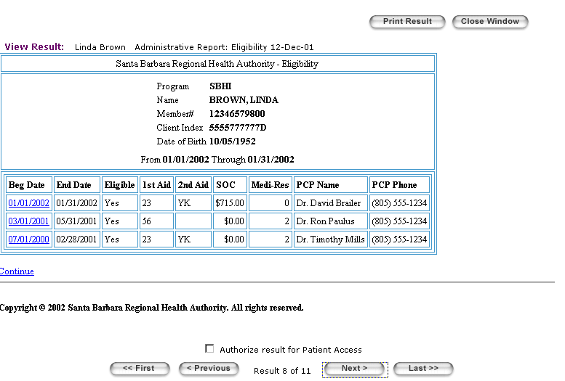
View Notes
The Clinician User needs to be able to view Consumer-entered notes. When notes are available to be read, an icon will appear on the line for that Person.

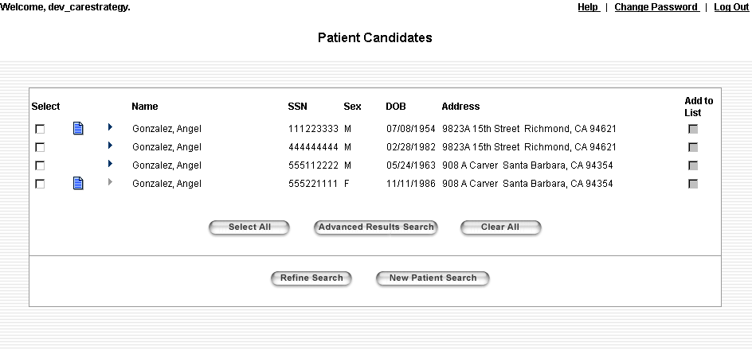
When the Clinician selects a note icon, a note will appear under the Person and the icon will change to show that the note can be hidden again.

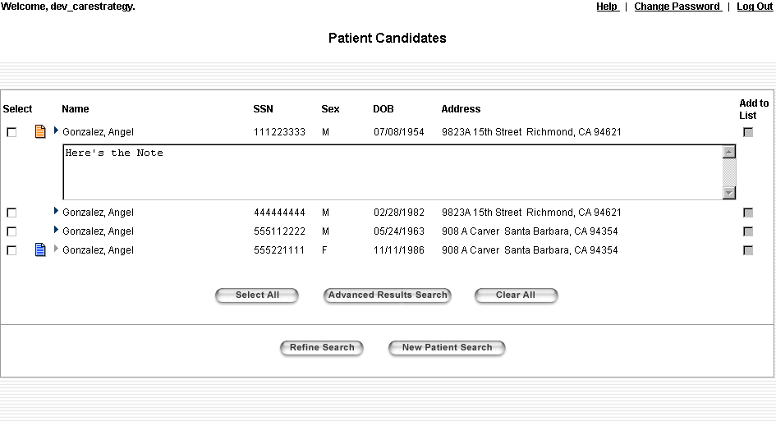
The note will appear below the aliases if they are expanded. The user should also be able to see notes for multiple Persons at one time, just as he can view aliases for multiple Persons.

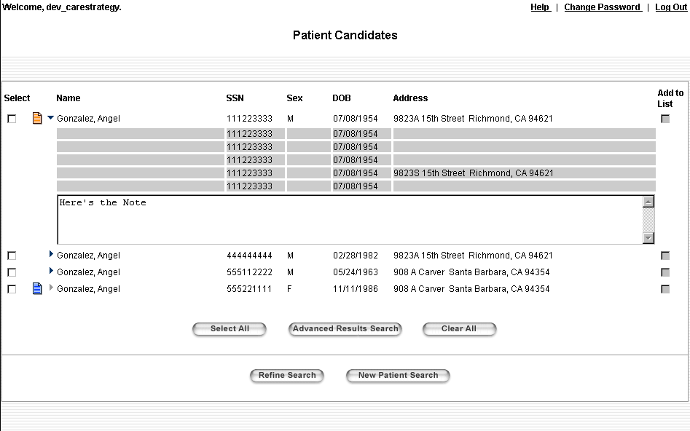

From Consumer Portal

ICS Access
Person retrieveUser(String userName)

This method should return the Person object based on the consumer’s login ID.

The first page the Consumer will see after the login will be the Candidate Search page with his or her information displaying.

ICS Note
The Consumer will be able to modify a Note field from the Candidate Search page. This will allow the user to update address information or provide a comment on results.

String getNote(Person consumer)

This method should retrieve the Consumer’s demographic Note.

void setNote(Person consumer, String note)

This method should set the Consumer’s demographic Note

ILS Results
As described above, only results that have been authorized should be returned in the Consumer Portal. The locator adapter call needs to contain the Portal from which the call originated.

Consent Logs
ArrayList getConsentLog(Person consumer, Date fromDate, Date thruDate)

Don’t need location, as a parameter, per Andrea, 06-May-02. This needs to return a Collection (of HashMaps maybe?) that contains the Consent Logs for the user

Screen Flow
When the Consumer logs in he will go to the My Demography Screen. From here he can update his Notes and View his Aliases.

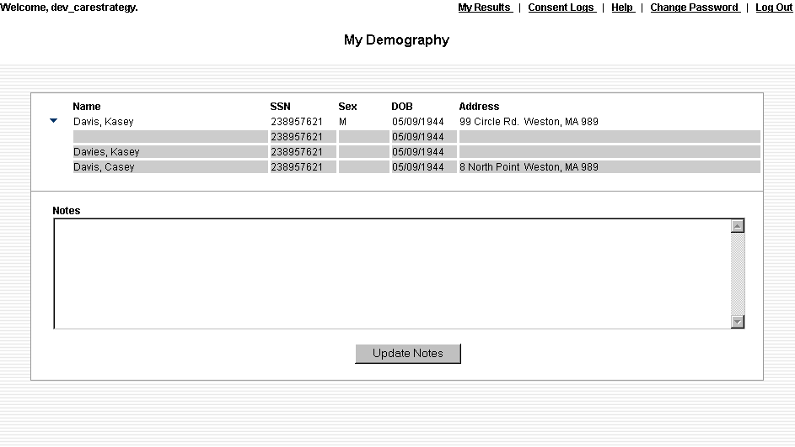
To access his results, the Consumer will hit the My Results link from the top of the screen. The Locate My Results and My Results screens are practically identical to the Clinician Portal, except some buttons were removed/altered, unneeded checkboxes were removed, etc.

Note the Consumer should not get the Consent Dialog box when trying to access his results.

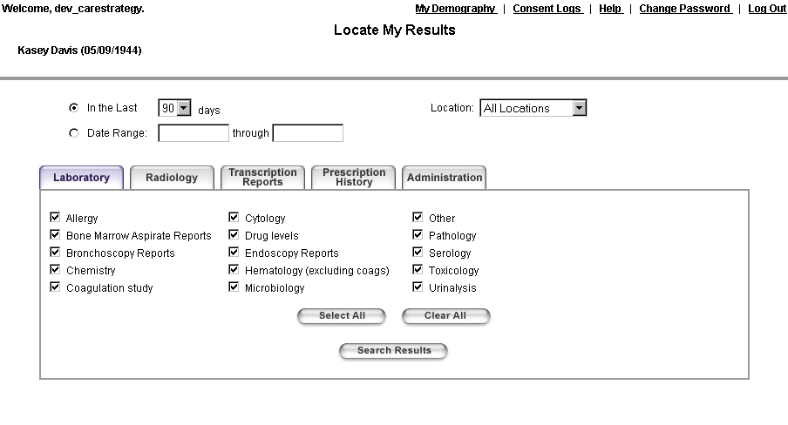
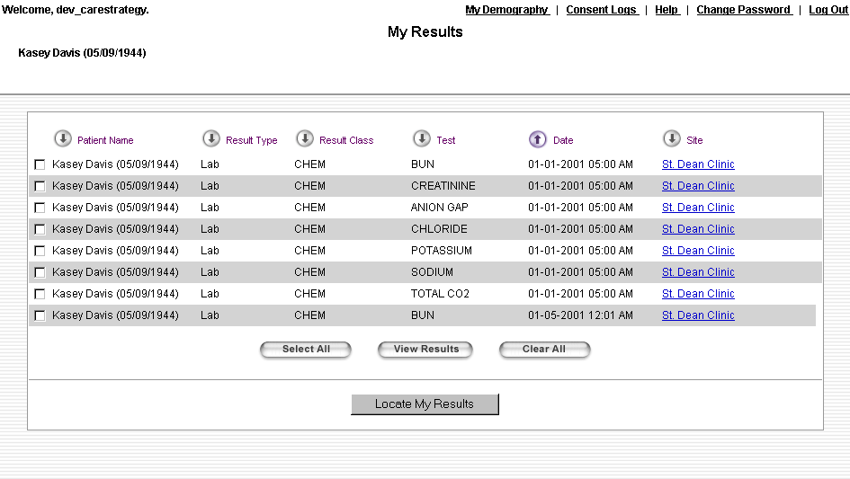
To access the Consent Logs, the Consumer will hit the Consent Logs link from the top of the screen. This screen will default to showing the Consent Logs for the past 90 days.

